Parkwood Residents Association recommended trees

Minor Trees pp. 1-3
Major Trees pp. 4-6

MINOR TREES

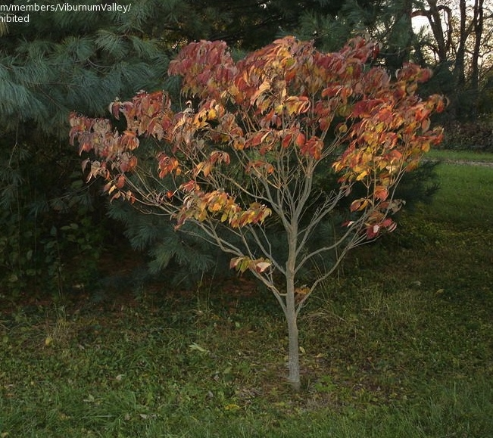
Dogwood, Cornus florida ‘Cherokee princess’
(white blooms)
‘Rubra’ has pink blossoms, good disease
resistance, won’t burn in sun

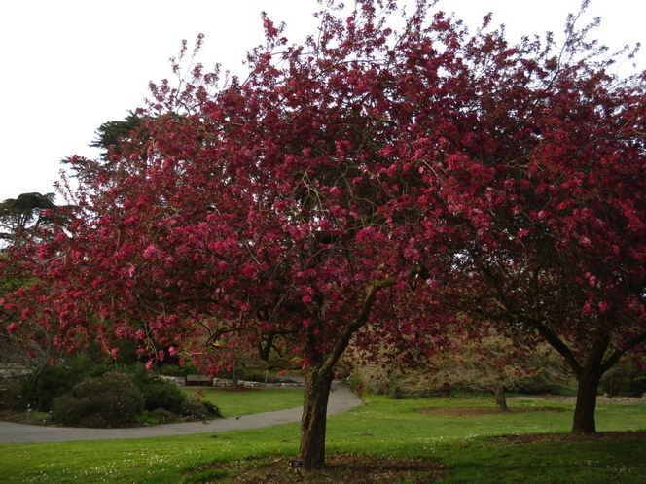

Crabapple, Malus (with strong disease resistance)
fruit, rounded dense habit 15-20',

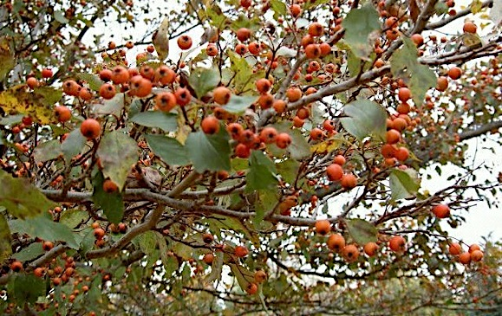
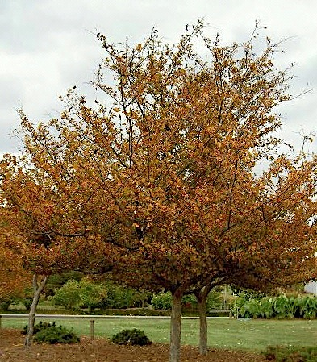
Winter king hawthorn, crataegus viridis—
Lovely red berries all winter, great winter interest
white blooms mid-may, best resistance of
hawthorns, may need a spray now and then

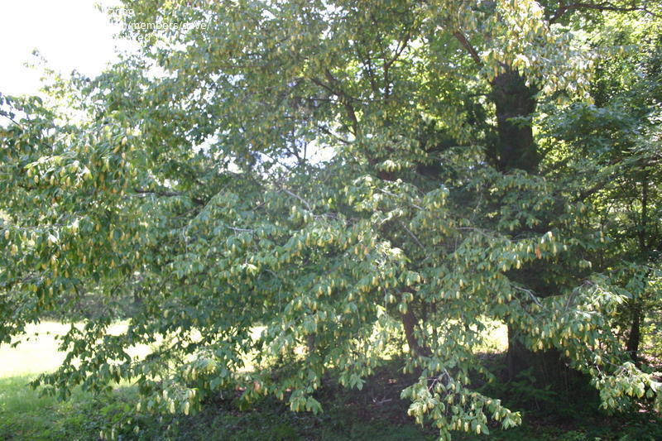
Ironwood Ostrya virginiana (hop hornbeam);
NATIVE tree, beautiful structure and leaf texture

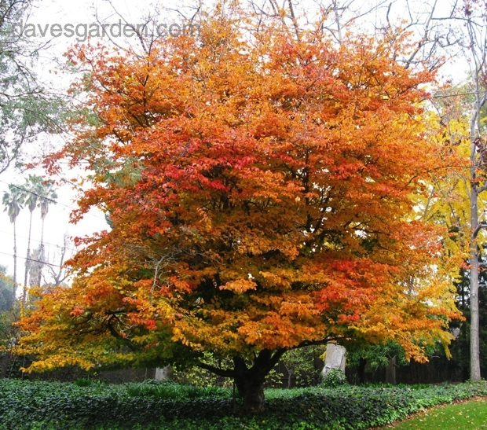

Parrotia persica, gorgeous fall color
Prune when young, 30 ft, tough, drought tolerant

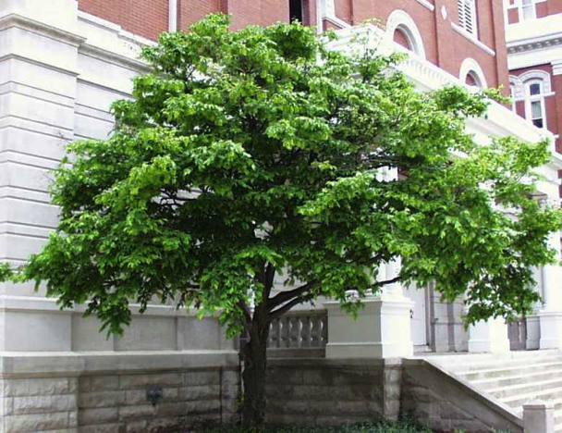
American hornbeam carpinus caroliniana
20-30 ft, prefers moister, hardwood, likes
some shade

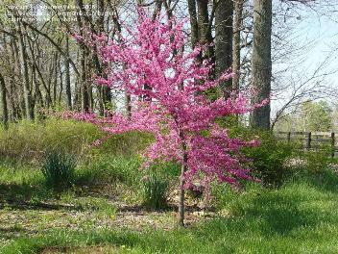
Redbud—cercis—white or pink bud varieties

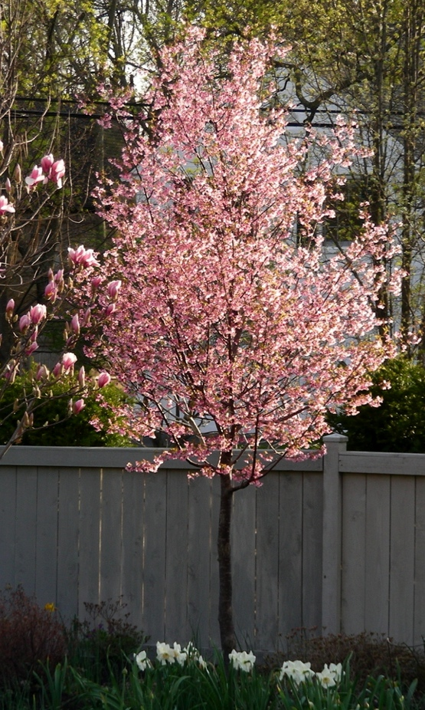

Okame cherry, prone to lots of problems which
Plague cherry trees, but Okame the best of
the bunch
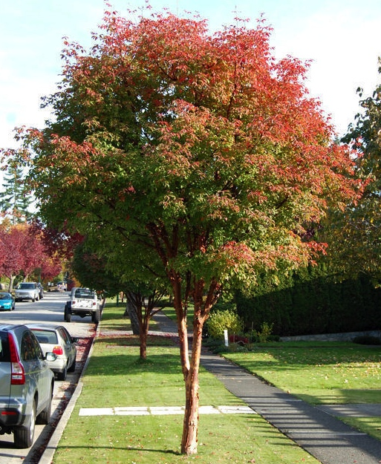
Paperbark maple, gorgeous: 4 season interest,
lovely bark

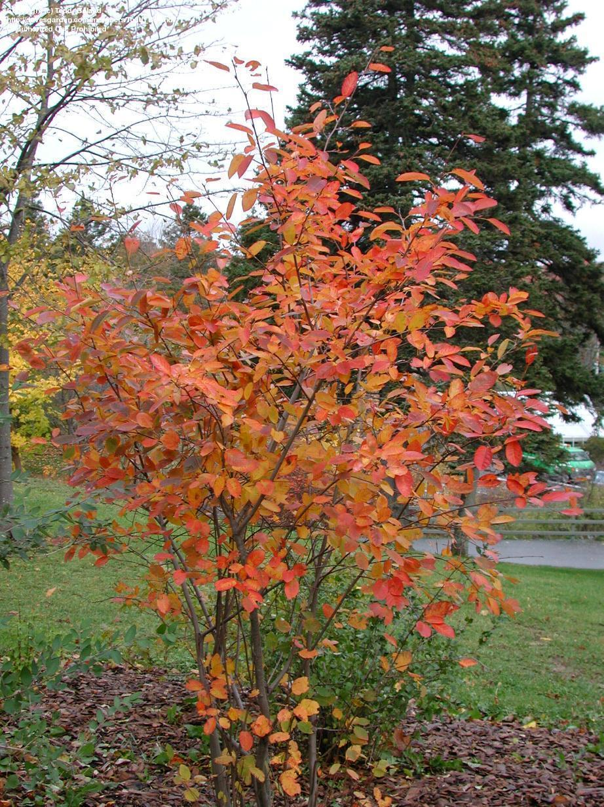
Amelanchier laevis Serviceberry, has fruits,
A Native shrub, nice fall color, prefers some
shade

MAJOR TREES

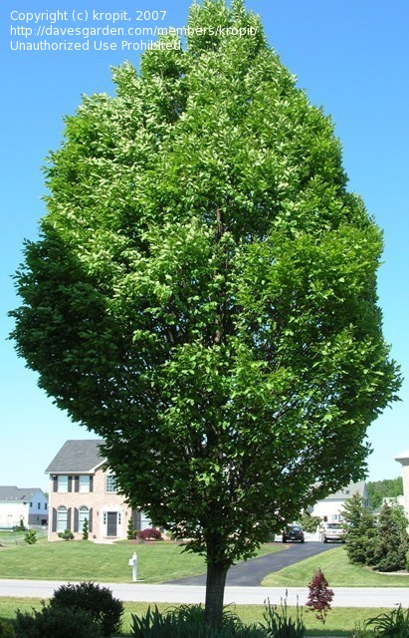

Carpinius betulus European hornbeam
(dense and formal shape)

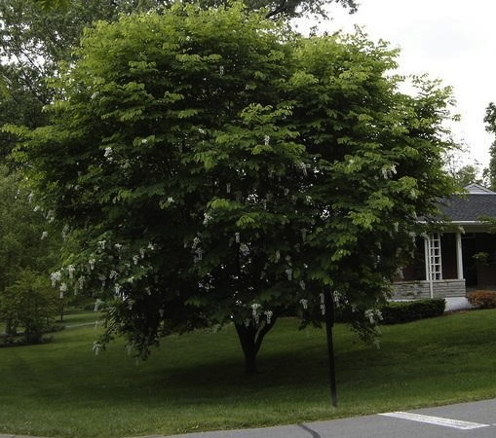
Cladrastis lutea (yellowwood), NATIVE tree,
lovely with gorgeous fragrant white pendulous
blooms, (this photo doesn’t do it justice)

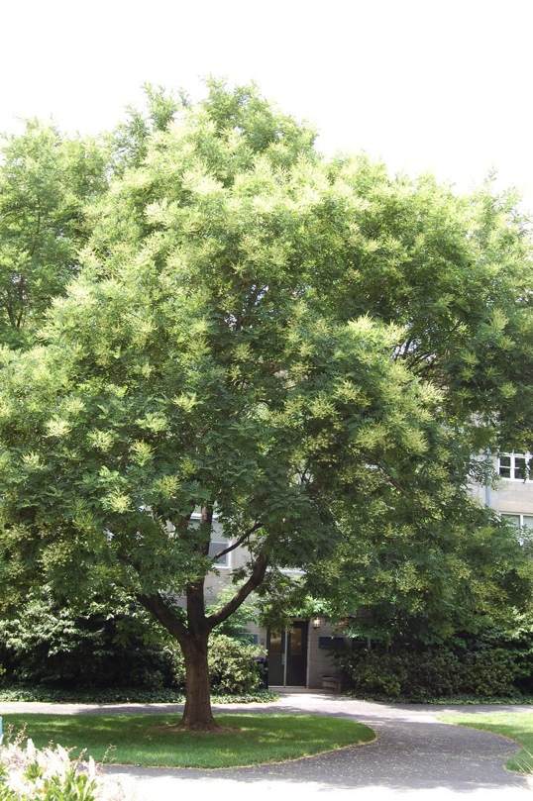

Japanese pagoda tree (Regent) (summer
blooming), airy and open

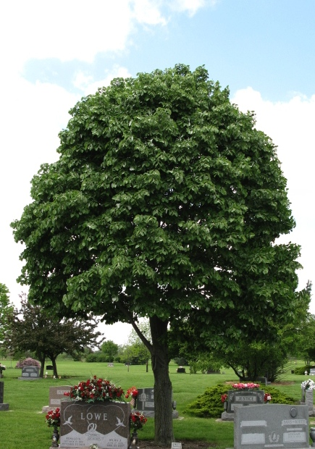
Silver linden, very fragrant hidden blooms,
A lovely tree
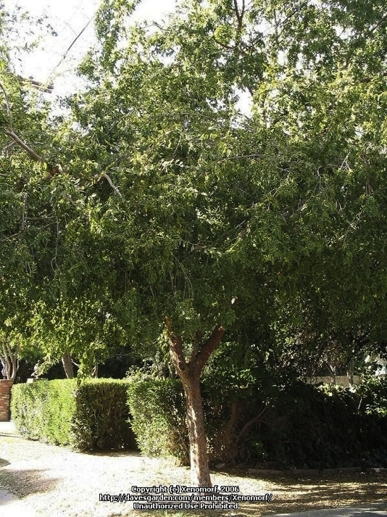
Lacebark elm, ulmus parvifolia, gorgeous shape
and easy to maintain

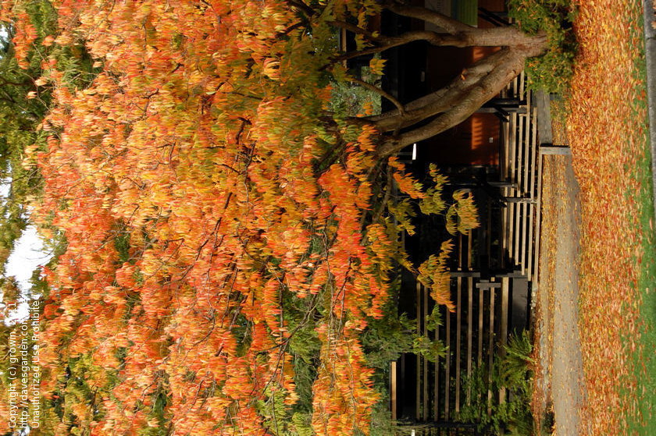

Zelkova serrata, (in the Elm family, gets to be
quite tall)
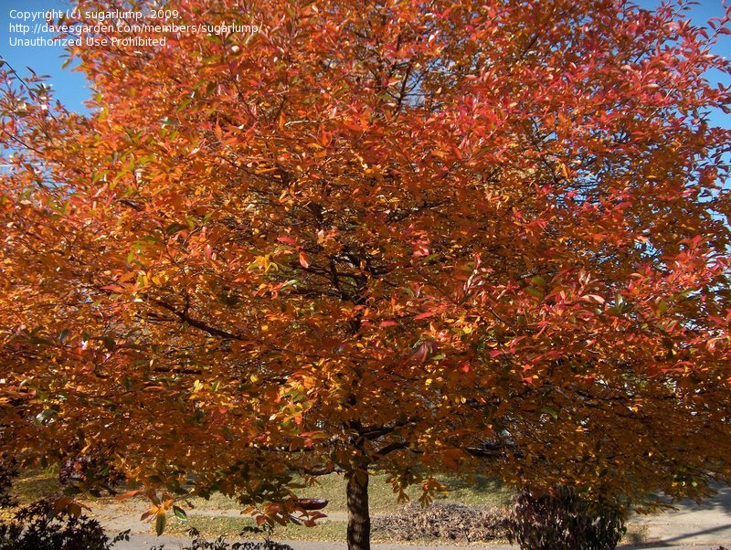
Black gum, Nyssa Sylvatica—gorgeous tree, good
for southern heat, may need some moisture
(great to plant at bottom of a hill or hollow)

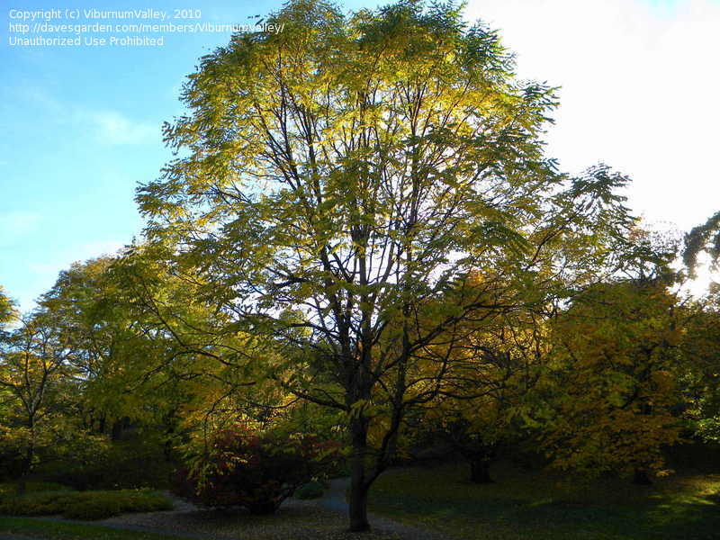
Kentucky coffee tree, slow growing, great urban
tolerance, to 70 feet or bigger, NATIVE, unusual,
Good winter interest (bark), yellow fall color,
Gentle shade

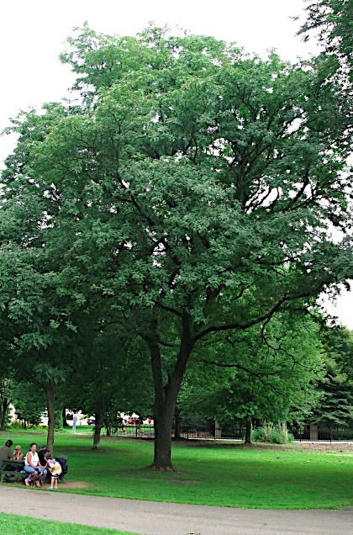
Thornless honey locust
Gleditsia triacanthos
fast growing, drought resistant,
lovely dappled shade, small leaves can
be less of a chore to rake, 40-50 ft

Others on county list but not included here:

Beeches (too big for distance to houses, disrupts foundations, best for countryside, parks)

Bald cypress (found in swamps, creeks,
best in flooding conditions, not streets)

Koelreuteria--Golden lantern tree widely reported as invasive in hot climates

Liquidambar styraciflua
Sweet gum—very very big, huge spiky seed balls, messy (sterile version is best)

Quercus myrsinifolia—oak not thriving in the area

London planes and oaks—too big, roots tend to fail in high wind

Valley Forge Elm, better for northern climes

Styrax japonicas—more of a shrub, needs water

Syringa reticulata—lilac—small for a street tree, shrubby

Cornus Kousa, gorgeous but wide,
low-branched small tree, better for yard

hedge maple amur campestris—small shrubby, boring, not well-received

acer ginnala—small maple, brittle, not
well-liked by owners, suckers, shortlived

